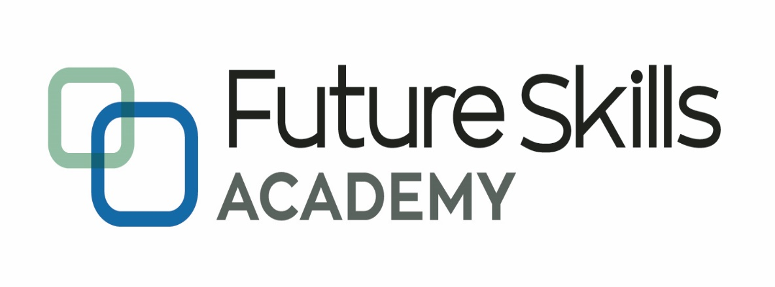

*Capable People, Capable Communities*

**Micro-Credentials in Software Development**

**Certificate in Intermediate Software Development**

**MCSD 61**

**Project Proposal**

**Maria Holgado**

**Sowmiya Purushothaman**

**Hasnaa Hady**

**September 2023**

Contents

**1.** **Introduction** 3

**2.** **User stories and use cases** 4

**3.** **Project Methodology** 6

**4.** **Project timeline***.* 6

**5.** **Problem domain sketch and use case diagrams** 8

**6.** **References** 11

# Introduction

* 1. ***Project background***

*Future Skills Academy enrols over 1000 students annually into any one of our 5 programme areas, namely, Health, Construction, IT (Software Development and Business Intelligence), Building Control, Early childhood education and Literacy and Numeracy. A new department was established in early 2023 to focus on stakeholders and industry relationships. The focus of this department is in four main areas of interaction with organizations, which are: In-work/corporate training, placements, employability, and programme advisory.*

*This project focuses on creating an up to date and relevant database of key stakeholders, and in return for their details, offer them something (“giveaway”), that is mutually beneficial for their details. The initial plan would be for the Building Control programme area for use at a Building Officials expo, but the application will be built in a way that can be adapted to different industries and contexts.*

*Digital business cards offer several advantages over traditional paper-based cards. Firstly, they are cost-effective as they eliminate the expenses associated with printing and designing physical cards. Instead, you can easily share your contact information electronically, saving both time and money. Secondly, digital business cards are easy to share and can be instantly sent through various channels like email, social media, or QR codes. This makes it convenient for networking events and enables you to connect with new contacts remotely. Additionally, digital business cards are more environmentally friendly as they reduce paper waste and promote sustainability. They are also accessible from anywhere with an internet connection and can be easily updated. Overall, digital business card gives a professional, modern image while offering convenience and versatility.*

*Therefore, this project aims to develop an application that can be used to generate digital business card that allows stakeholders to share it with others.*

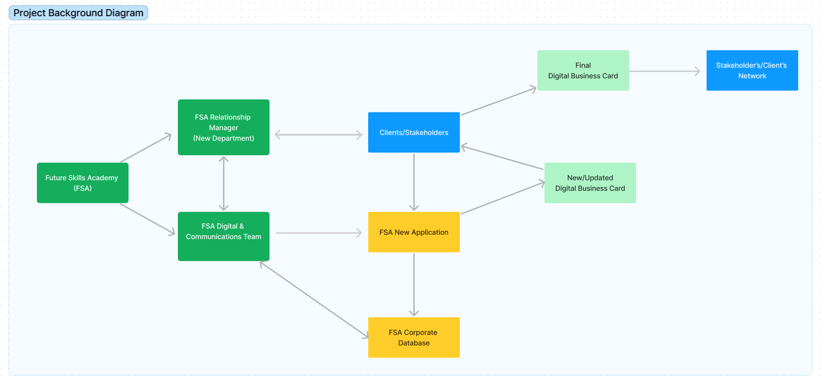

* 1. ***Stakeholders***

1. *Future Skills Academy: The organization initiating the project and will be the primary user of the application.*
2. *Clients and Stakeholders: Individuals and organizations that attend expos, conferences, and other events and will benefit from the digital business card.*
3. *Digital and Communications Team: Responsible for creating digital business cards for Future Skills Academy's internal team.*

*1.3* ***Objectives***

1. *Develop an application that generates digital business cards for clients to share with their networks.*
2. *Capture contact details that can be incorporated to current corporate database of Future Skills Academy.*
3. *Make use of the application to provide a valuable giveaway (digital business card) for individuals who share their details with Future Skills Academy at events.*

*1.4* ***Expected outcomes***

1. *Eliminate the use of paper forms when inputting information (Application).*
2. *Generate a professional, modern image of contact information (Digital Business Card).*
3. *Improved efficiency and convenience in sharing contact information (QR code or Share information function).*
4. *Up-to-date and relevant databases of key stakeholders (Update function).*

# User stories and use cases

*These user stories and corresponding use cases cover a range of functionalities that users would expect in this digital business card application. They include features like including profile photo image or logo (optional), website or LinkedIn profile link, QR code generation and sharing options.*

***User Story 1:***

*As a user, I want to easily create my digital business card with my contact information.*

***Use Case 1: Creating a Digital Business Card***

*Description: The user creates a digital business card with their contact information.*

***Main Success Scenario:***

*1. User selects the "Create New Card" option.*

*2. User enters their contact details, such as name, company name, job title, mobile number, and email address.*

*3. User uploads their profile picture and selects logo for their digital business card (optional).*

*4. User adds additional elements like website or LinkedIn profile links (optional).*

*5. User receives URL and QR Code to his Digital Business Card*

*6. User opens the Digital Business Card to his mobile phone*

*7. User adds the Digital Business Card to mobile home screen for easy access.*

***User Story 2:***

*As a user, I want to easily update my digital business card.*

***Use Case 2: Updating a Digital Business Card***

*Description: The user opens the digital business card and utilizes the update link to easily modify their information.*

***Main Success Scenario:***

*1. User accesses his Digital Business Card from his mobile home screen*

*2. User clicks the update link from the digital business card*

*3. User is directed to the authentication link (code sent through email or sms).*

*4. User updates the information.*

*5. User uploads profile picture and selects logo for their digital business card (optional).*

*6. User adds additional elements like website or LinkedIn profile links (optional).*

*7. User receives URL and QR Code to his Digital Business Card*

*8. User opens the updated Digital Business Card to his mobile phone*

***User Story 3:***

*As a user, I want to be able to share a unique QR code for my digital business card to facilitate quick and convenient contact saving for recipients.*

***Use Case 3: Generating QR Code***

*Description: The user generates a unique QR code linked to their digital business card for easy contact saving or information sharing.*

***Main Success Scenario:***

*1. User accesses their digital business card*

*2. User selects the option to generate a QR code.*

*3. User saves or downloads QR code for distribution.*

***User Story 4:***

*As a user, I want the ability to share my digital business card via email or messaging apps.*

***Use Case 4: Sharing via Email/Messaging***

*Description: The user shares their digital business card with others through email or messaging apps.*

***Main Success Scenario:***

*1. User selects the "Share" option in their digital business card.*

*2. URL link automatically copied to clipboard*

*3. User sends the URL of the digital business card to the recipient.*

# Project Methodology

*Our project methodology for developing a digital business card will be based on* ***Agile principles****. By utilizing the* ***Scrum framework using JIRA****, emphasizing flexibility and collaboration. Regular sprint planning, stand-ups, reviews, and retrospectives will guide our progress, ensuring effective communication and progress tracking. With risk management, quality assurance, and client feedback, we will strive to meet all requirements within the agreed timeframe. Our Agile approach allows us to adapt to changes and deliver valuable features throughout the development process, while maintaining open communication and collaboration with our team and stakeholders.*

*Current JIRA Project Board*

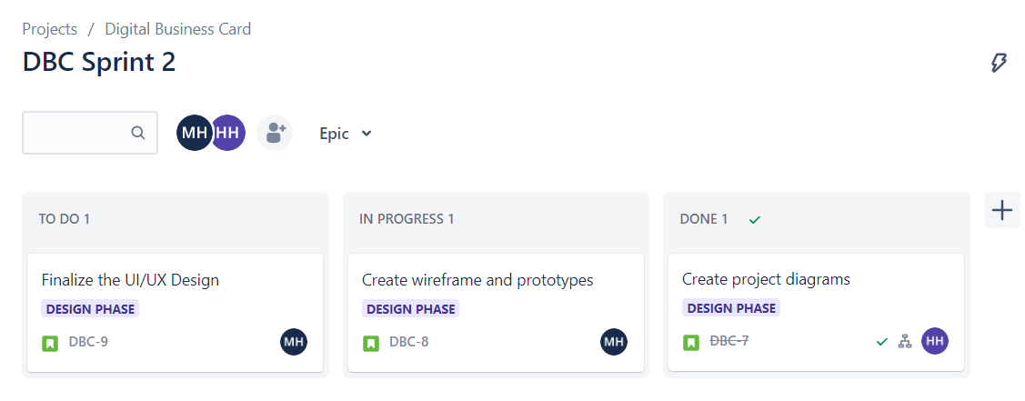

# Project timeline*.*

*Here is a rough project timeline for a 12-week digital business card project:*

*JIRA Project: Digital Business Card -* [*https://mcmr.atlassian.net/jira/software/projects/DBC/boards/2/timeline?timeline=WEEKS&shared=&atlOrigin=eyJpIjoiMzlhZjljYzkzMTc4NDMwMjgyMGEwZGZhNzkyMmFhOTgiLCJwIjoiaiJ9*](https://mcmr.atlassian.net/jira/software/projects/DBC/boards/2/timeline?timeline=WEEKS&shared=&atlOrigin=eyJpIjoiMzlhZjljYzkzMTc4NDMwMjgyMGEwZGZhNzkyMmFhOTgiLCJwIjoiaiJ9)

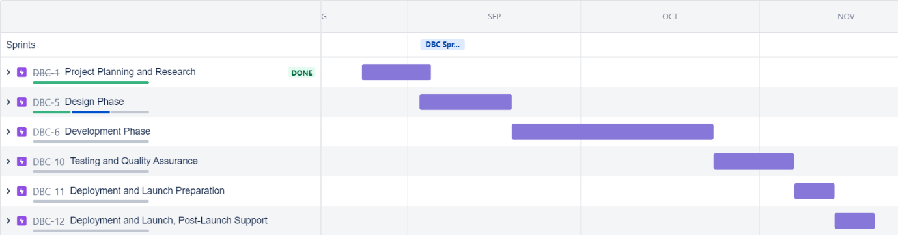

*1. Week 1-2: Project Planning and Research*

*- Define project goals and objectives.*

*- Conduct research and analyze competitors (if applicable)*

*- Gather user requirements*

*2. Week 3-4: Design Phase*

*- Create Project Diagram*

*- Create wireframes and prototypes for the digital business card application.*

*- Finalize the UI/UX design.*

*3. Week 5-8: Development Phase*

*- Set up the development environment.*

*- Implement the core functionalities of the digital business card, such as creating and updating cards, integrating contact information, and linking LinkedIn profile or website link.*

*- Perform regular testing and debugging.*

*4. Week 9-10: Testing and Quality Assurance*

*- Conduct thorough testing of the application to identify and fix any bugs and issues.*

*- Optimize the performance and ensure compatibility with different devices and platforms.*

*- Gather user feedback and make necessary adjustments.*

*5. Week 11: Deployment and Launch Preparation*

*- Prepare for deployment, such as setting up servers and databases.*

*- Conduct final testing on the production environment.*

*6. Week 12: Deployment and Launch, Post-Launch Support*

*- Launch the digital business card application*

*- Monitor the application's performance and address any user-reported issues.*

*- Provide ongoing support and maintenance.*

# Problem domain sketch and use case diagrams

*Using Figma Board – Digital Business Card*

[*https://www.figma.com/file/fbB147dv8ech8TPVMVe17b/Digital-Business-Card-(Community)?type=whiteboard&node-id=0%3A1&t=OW7SvW781XtfWEFm-1*](https://www.figma.com/file/fbB147dv8ech8TPVMVe17b/Digital-Business-Card-(Community)?type=whiteboard&node-id=0%3A1&t=OW7SvW781XtfWEFm-1)

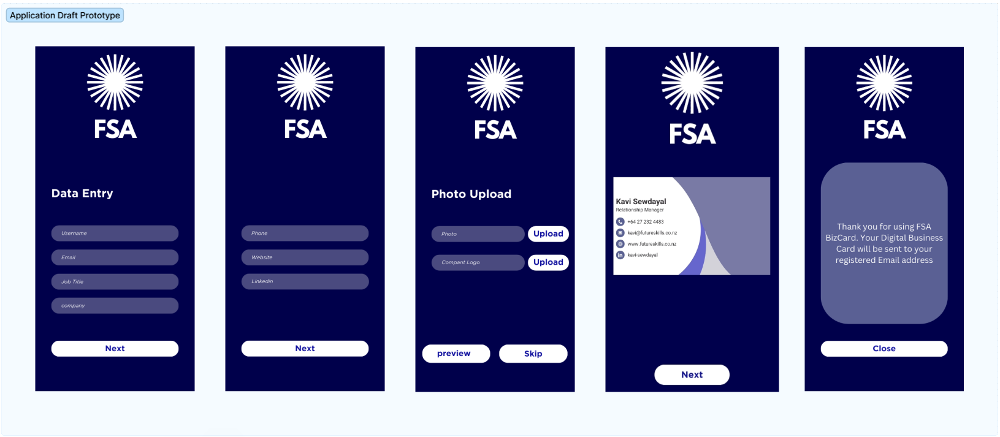

# References

DENSO WAVE INCORPORATED (n.d.). QR Code API. QR Code Generator. Retrieved August 28, 2023, from <https://goqr.me/api/>

[GreatStack]. (2023, January 25). How To Make QR Code Generator Website Using HTML CSS And JavaScript [Video]. YouTube. <https://www.youtube.com/watch?v=g1j9rR-H1lk>

Your Million Coder (2022, September 13). How to make Profile/Business Card using #react ⚛️. YouTube. Retrieved August 30, 2023, from <https://www.youtube.com/watch?v=EEHHIUZuRQ0>

(2023, September 3). What is scrum and how to get started. Atlassian JIRA. Retrieved November 10, 2018, from <https://www.atlassian.com/agile/scrum>